[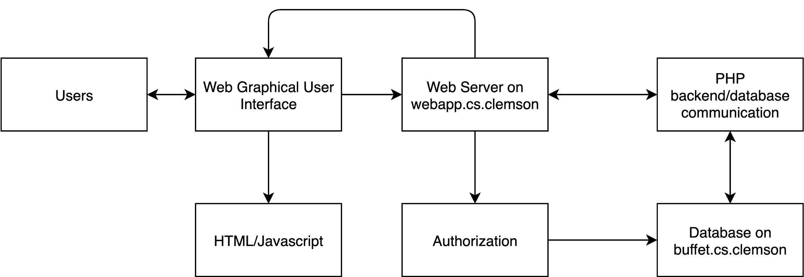](https://app.diagrams.net/?page-id=kgpKYQtTHZ0yAKxKKP6v&scale=auto#G16s9_ireB8i4YbbxNcuvyuXk3q8mOhj-w)